***IMAGE CAPTION GENERATOR APPLICATION***

INTRODUCTION

For a machine to be able to automatically describe objects in an image along with their relationships or the actions being performed using a learnt language model is a challenging task, but with massive impact in many areas. Being able to automatically describe the content of an image using properly formed English sentences is a challenging task, but it could have a great impact by helping visually impaired people better understand their surroundings.

### What is Image Caption Generator?

Image caption generator is a task that involves computer vision and natural language processing concepts to recognize the context of an image and describe them in a natural language like English.

PURPOSE

The objective of our project is to learn the concepts of a CNN and LSTM model and build a working model of Image caption generator by implementing CNN with LSTM

Most modern mobile phones are able to capture photographs, making it possible for the visually impaired to make images of their environments. These images can then be used to generate captions that can be read out loud to the visually impaired so that they can get a better sense of what is happening around them. We are creating a web application where the user selects the image and the image is fed into the model that is trained and generated caption will be displayed on the webpage.

LITERATURE SURVEY

EXISTING PROBLEM

You saw an image and your brain can easly tell what is the image is about....But a computer can tell what the image is representing?? Computer vision researchers worked on this a lot and they considered it to be impossible until now!! With the advancement in deep learning techniques ,datasets and computer power, we can build models that can generate captions for an image.

The problem introduces a captioning task, which requires a computer vision

system to both localize and describe salient regions in images in natural language.

The image captioning task generalizes object detection when the description

consist of a single word.

PROPOSED SOLUTION

In this Python project, we will be implementing the caption generator using [***CNN(Convolutional Neural Networks)***](https://data-flair.training/blogs/convolutional-neural-networks-tutorial/)and LSTM (Long short term memory). The image features will be extracted from Xception which is a CNN model trained on the imagenet dataset and then we feed the features into the LSTM model which will be responsible for generating the image captions.

•The proposed model has proven to be robust and able to accurately generate the captions for the images.

In this advanced Python project, we have implemented a CNN-RNN model by building an image caption generator

THEORETICAL ANALYSIS:

BLOCK DIAGRAM:

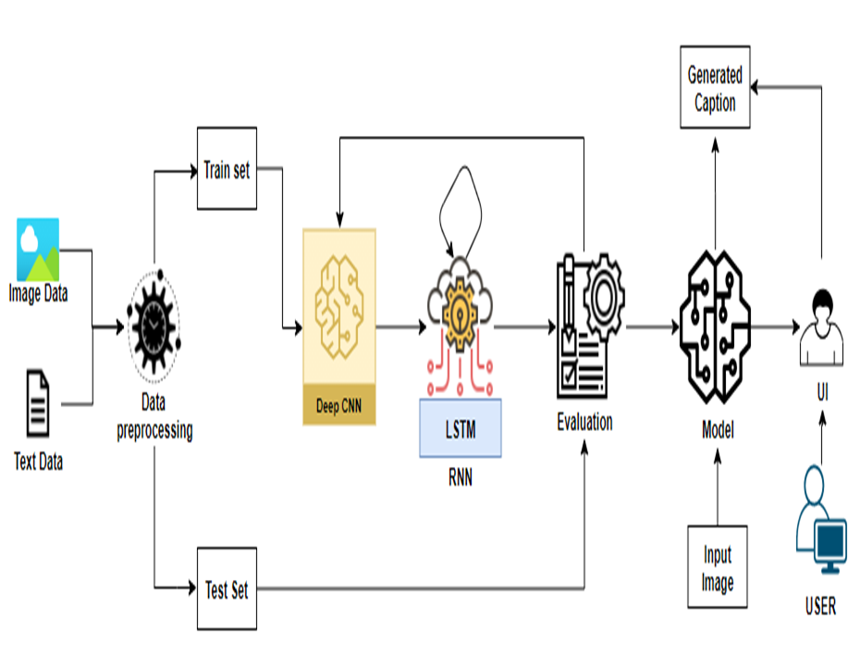

HARDWARE AND SOFTWARE REQUIREMENTS

This project requires good knowledge of Deep learning, Python, working on Jupyter notebooks, Keras library, Numpy, and [*Natural language processing*](https://data-flair.training/blogs/nlp-natural-language-processing/).

Make sure you have installed all the following necessary libraries:

* pip install tensorflow
* keras
* pillow
* numpy
* tqdm
* jupyterlab
* Python
* Flask

FLOWCHART

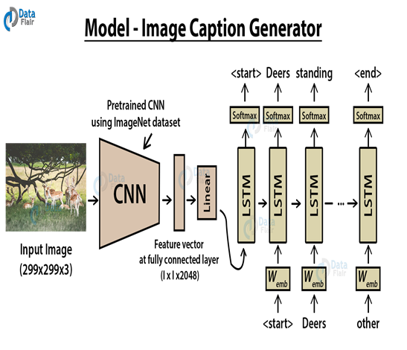

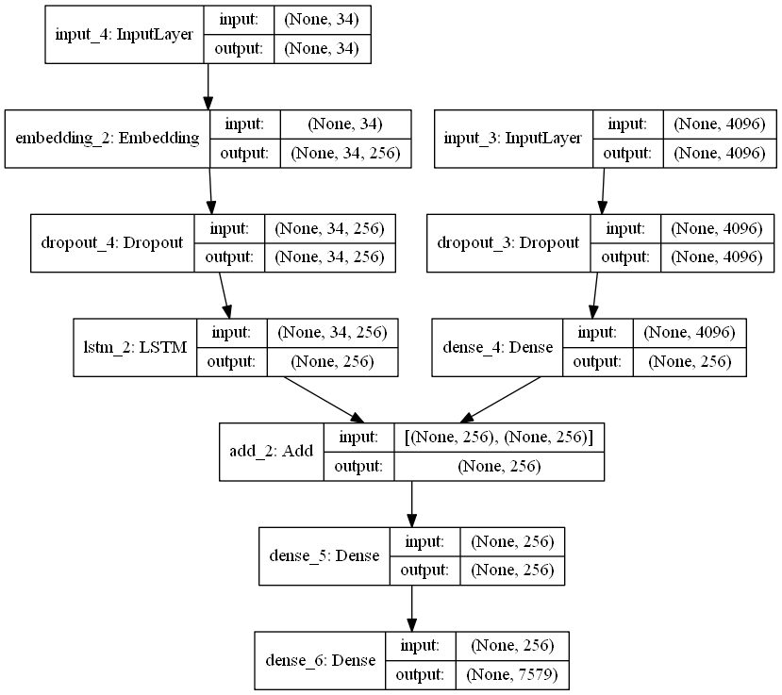

RESULT

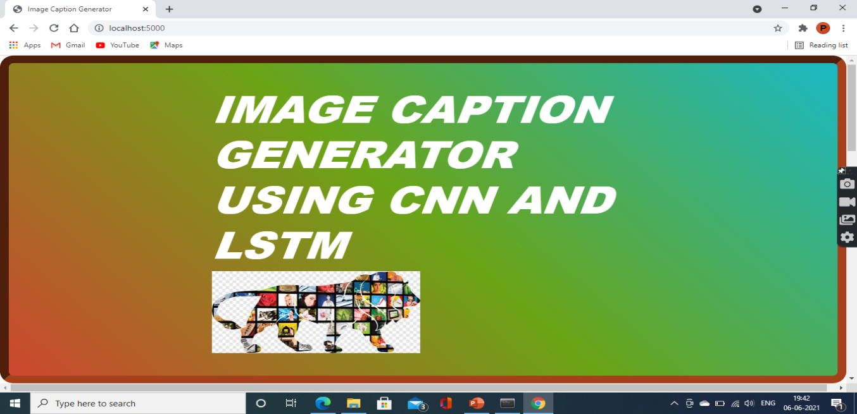

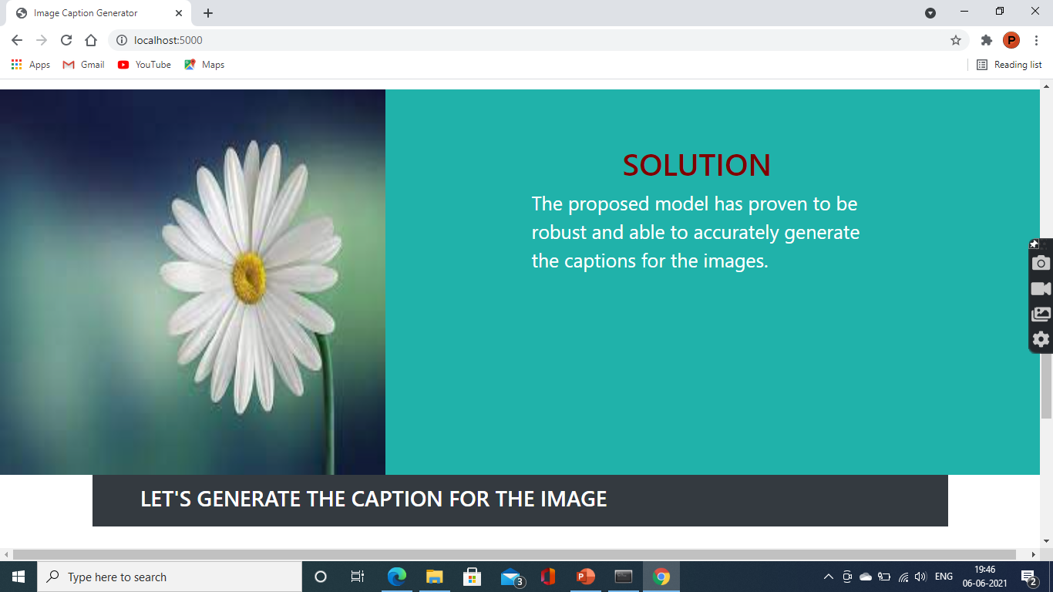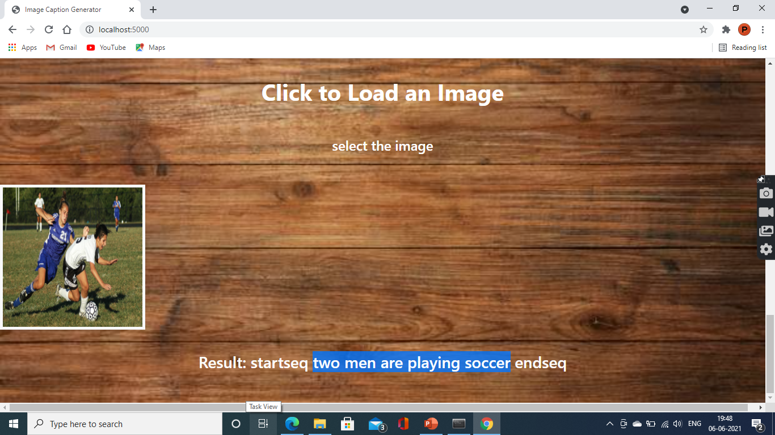

***ADVANTAGES AND DISADVANTAGES***

In everyday life, humans easily classify images that they recognize e.g. surrounding objects are easily identified, but the classification of images in the disease detection, video surveillance,vehicle navigation is a challenging and important task. To mitigate the risk,computers are trained to classify images using the various algorithm . Image Classification using CNN model is widely used as they are powerful in achieving high accuracy with minimum error rate. CNN’s have shown remarkable classification results using standard architectures .

### What is CNN?

Convolutional Neural networks are specialized deep neural networks which can process the data that has input shape like a 2D matrix. Images are easily represented as a 2D matrix and CNN is very useful in working with images.

CNN is basically used for image classifications and identifying if an image is a bird, a plane or Superman, etc.

[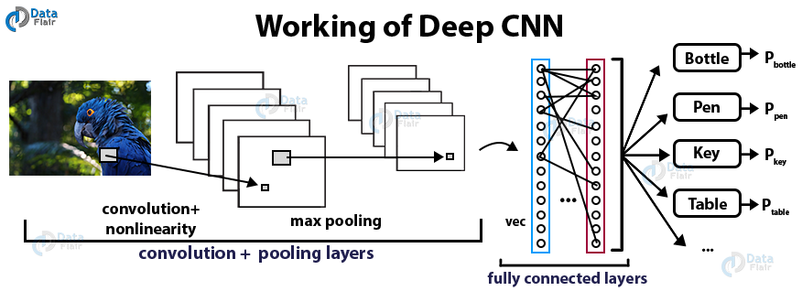](https://d2h0cx97tjks2p.cloudfront.net/blogs/wp-content/uploads/sites/2/2019/11/working-of-Deep-CNN-Python-project.png)

***APPLICATIONS***

**Image captioning** has various **applications** such as recommendations in editing **applications**, usage in virtual assistants, for **image** indexing, for visually impaired persons, for social media, and several other natural language processing **applications**.

***CONCLUSION***

We can easily identify any image immediately after seeing it, but it is hard for the computer to do the same. Nowadays, deep learning has unveiled such difficulties and has facilitated us to build an application which can identify any image. The caption of the image is based on the huge database which will be fed to the system. This machine learning project of image caption generator is implemented with the help of python language. This project will also need the techniques of convolution neural network and recurrent neural networks.

In this advanced Python project, we have implemented a CNN-RNN model by building an image caption generator. Some key points to note are that our model depends on the data, so, it cannot predict the words that are out of its vocabulary. We used a small dataset consisting of 8000 images. For production-level models, we need to train on datasets larger than 100,000 images which can produce better accuracy models.

***BIBLIOGRAPHY***

[Python based Project - Learn to Build Image Caption Generator with CNN & LSTM - DataFlair (data-flair.training)](https://data-flair.training/blogs/python-based-project-image-caption-generator-cnn/)

https://github.com/Guided-Projects/Image-Caption-Generator

APPENDIX

[SI-GuidedProject-2317-1622049672/Image-Caption-Generator-main at main · smartinternz02/SI-GuidedProject-2317-1622049672 (github.com)](https://github.com/smartinternz02/SI-GuidedProject-2317-1622049672/tree/main/Image-Caption-Generator-main)